Linux task-2 Mohammed Mujahed
- Create user with name Techie and provide sudo access to user.
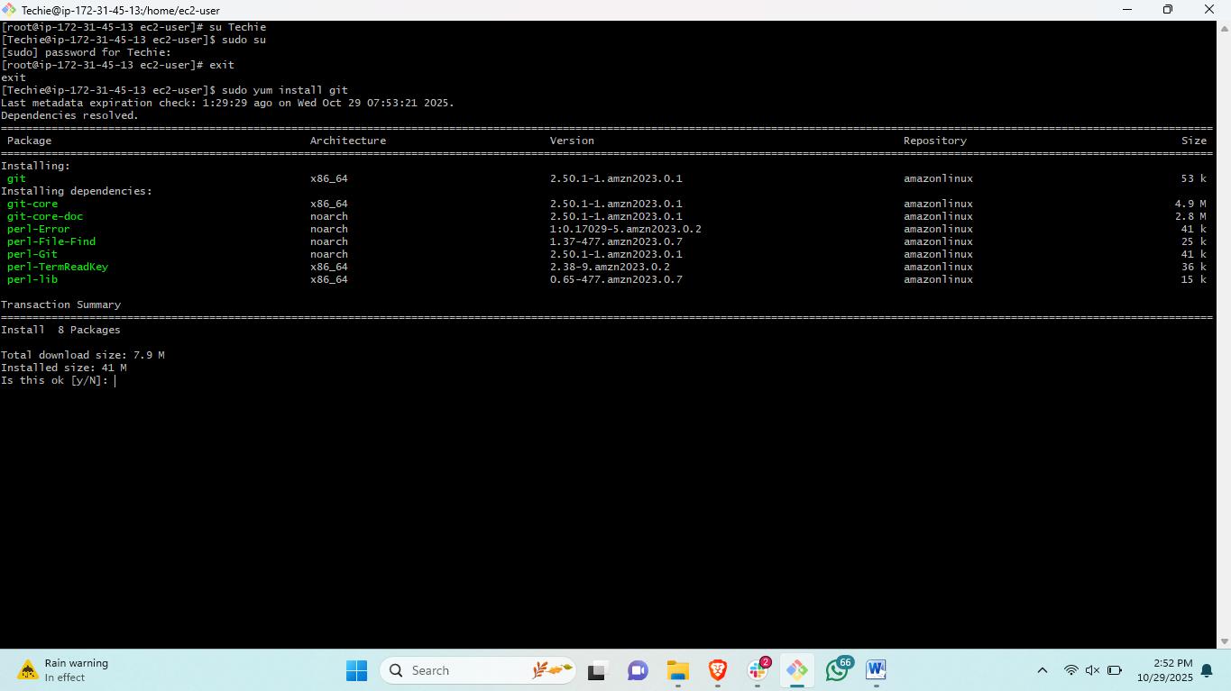steps: first create new user<sudo useradd Techie>
#then create password with <sudo passwd Techie>
#then edit the file for permissions< sudo vi /etc/sudoers>
#then change to user <sudo su Techie>
#then install git <yum install git>
2) Navigate to the home directory.
steps: # to change the directory <cd>
3) Create a new directory.
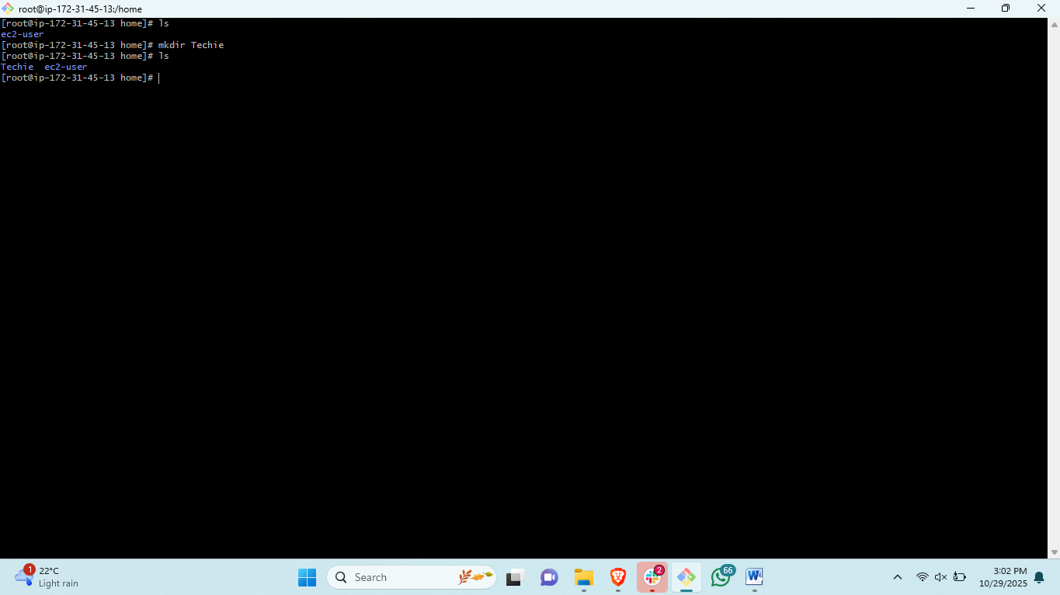steps: # to create directory<mkdir “directory name”>
4) List the contents of a directory.
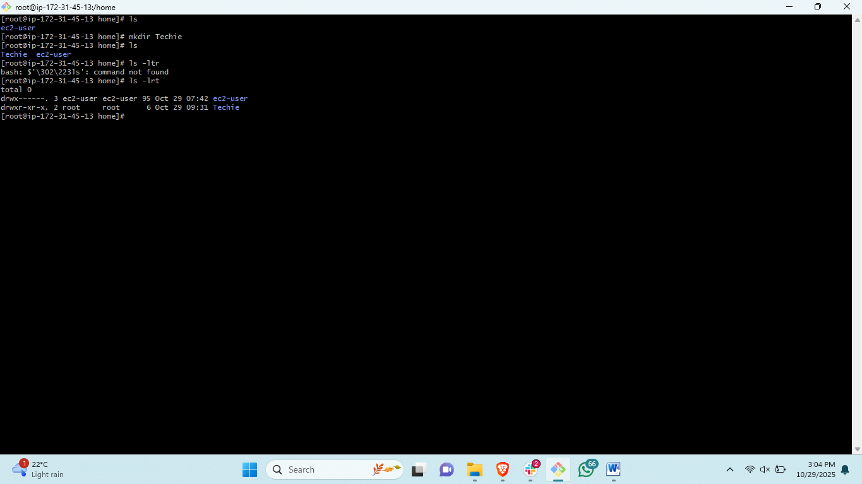steps: # to list the content of a directory with information <ls -lrt>
5) Change the current directory.
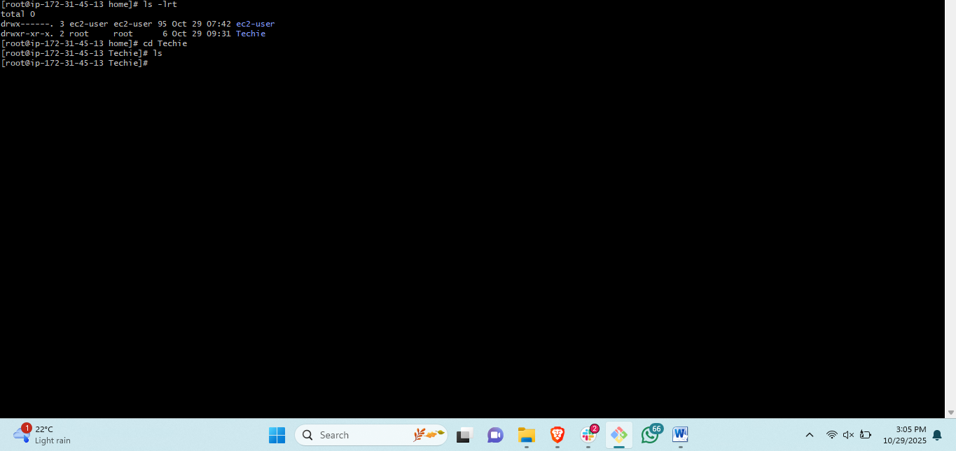steps: # change the directory location <cd>
6) Create a new empty file.
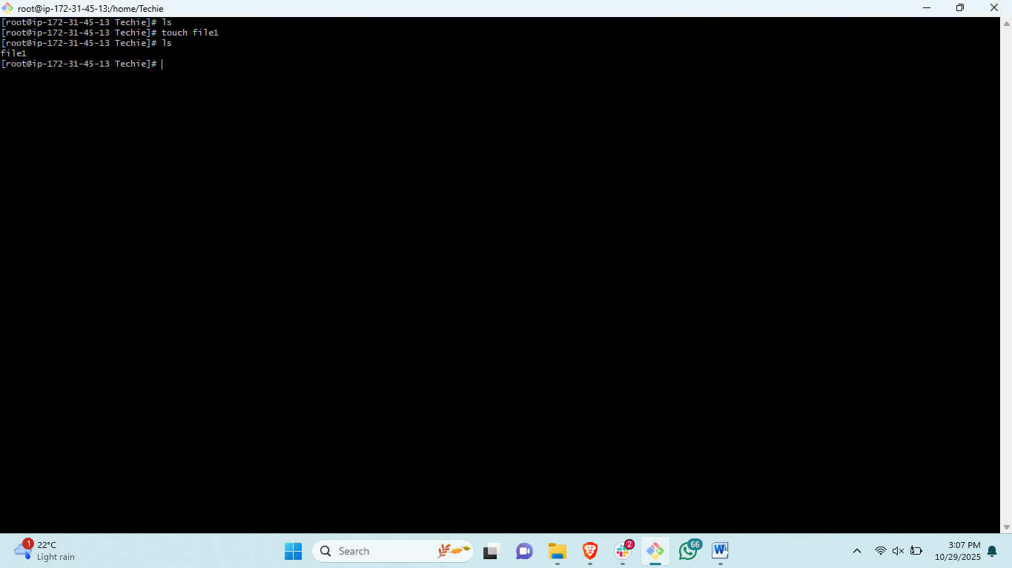steps: to create a new empty 0byte file<touch “filename”>
7) View the contents of a file.
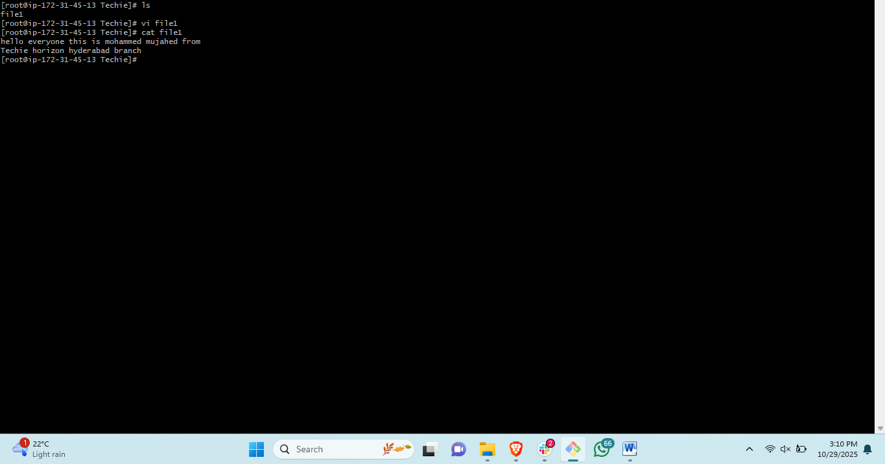
Steps: #to view the content of a file <cat “filename”>
8) Copy a file to another location.
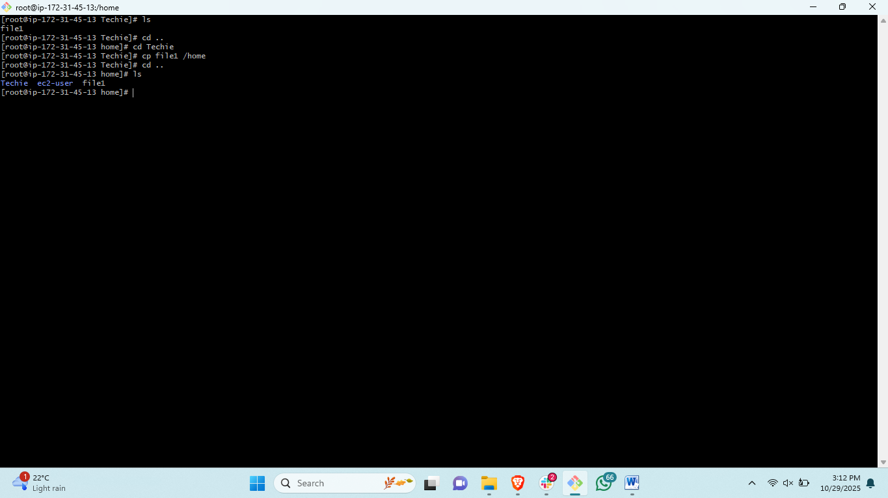steps: # to copy file from one location to another <cp “filename /destination” >
9) Move a file to another location.
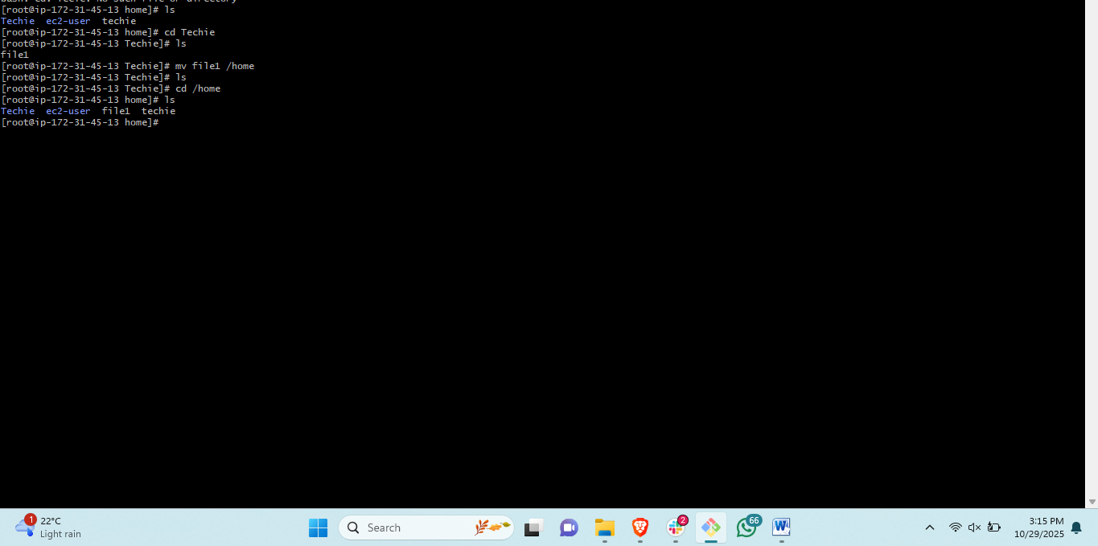 steps: # to move a file from one to another location <mv filename /destination>

10) Rename a file.
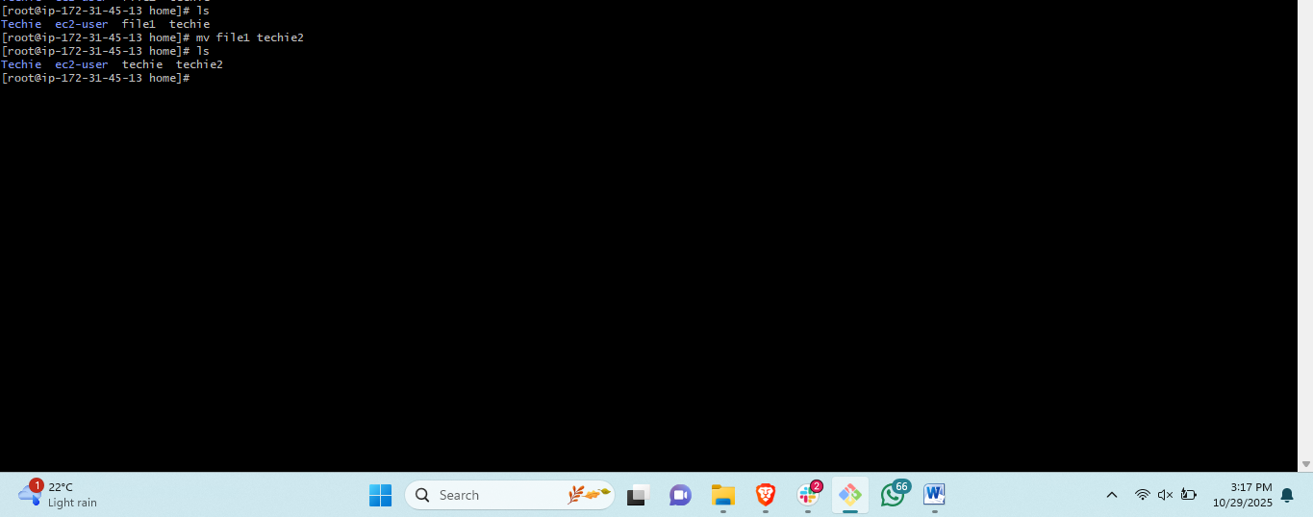steps: # to rename the file or directory<mv oldname newname>
11) Delete a file.
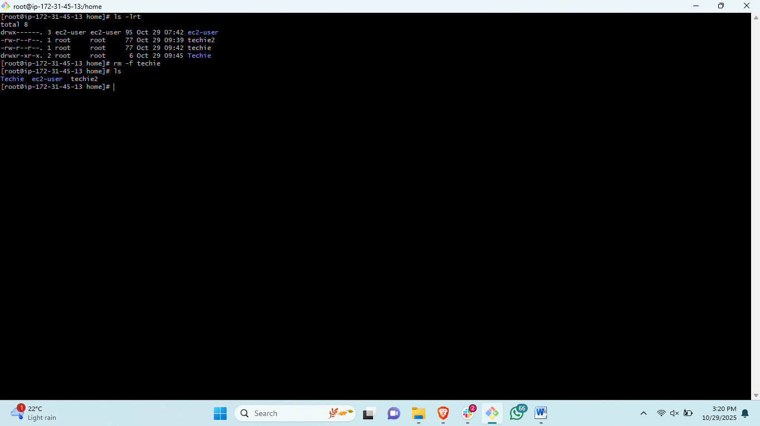steps: # to delete a file <rm –f filename>

12) Grant or revoke permissions on a file or directory.
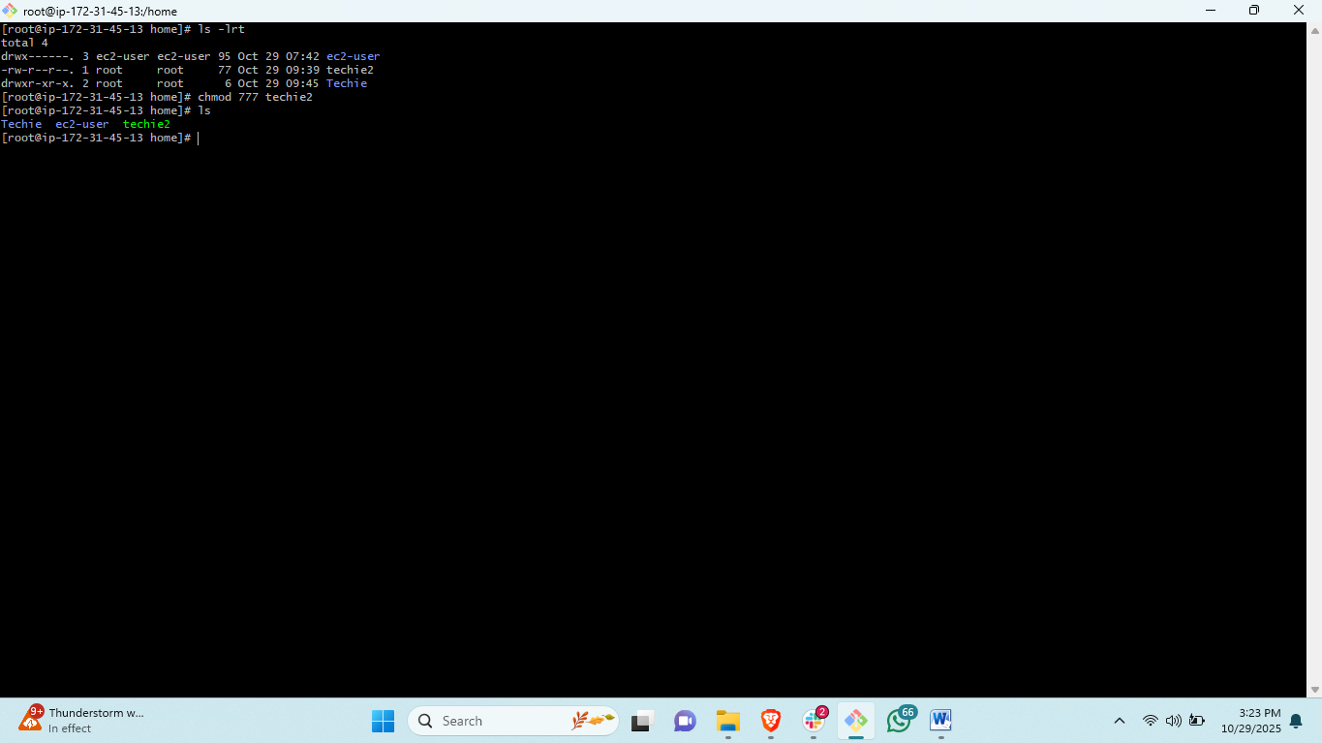
Steps # to add permission to a file <chmod 777 filename>
13) View the current date and time.
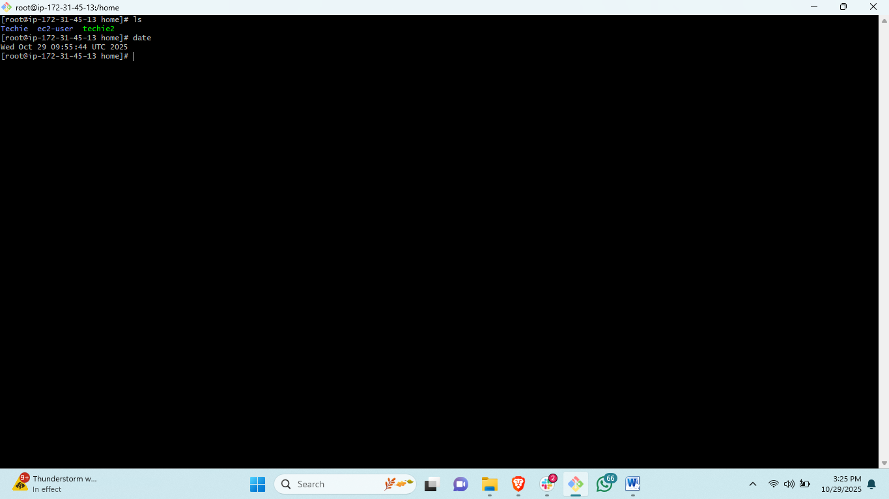steps: # to chack the date <date>
14) Check the system uptime.
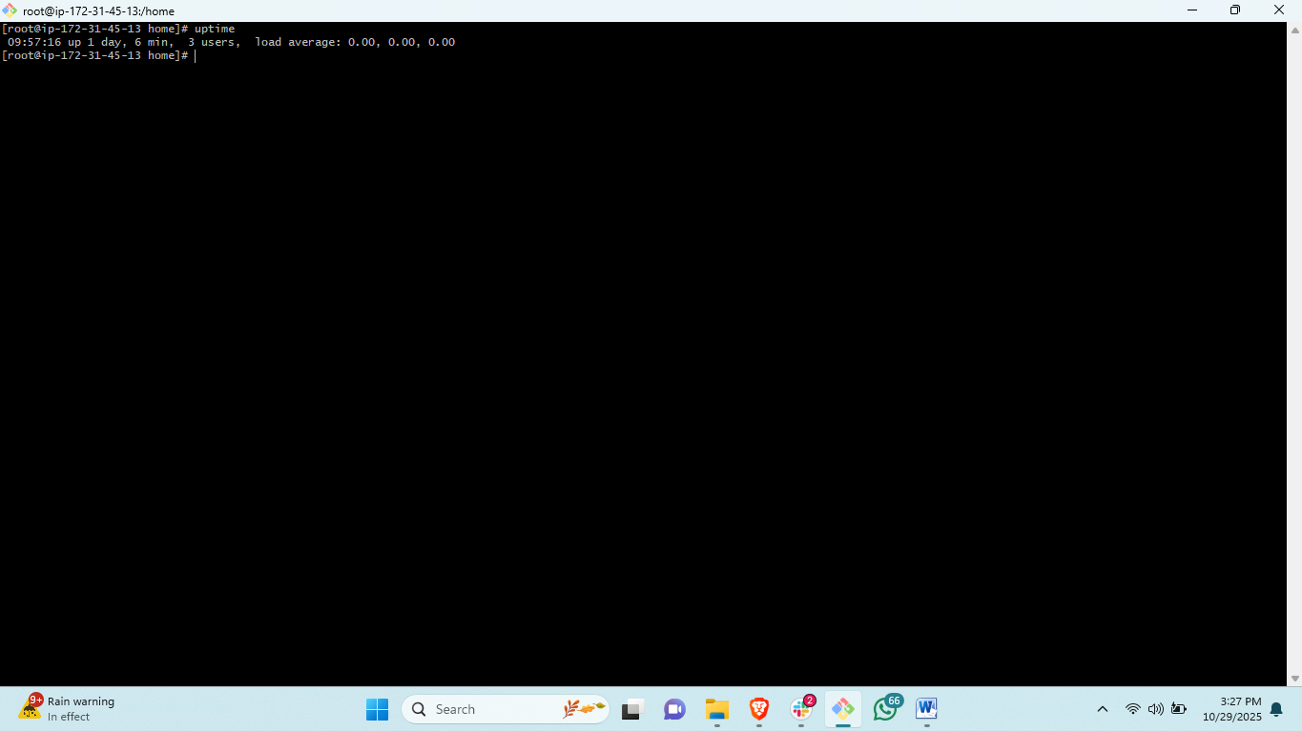steps : this is to check from when the system is running<uptime>
15) View the running processes.
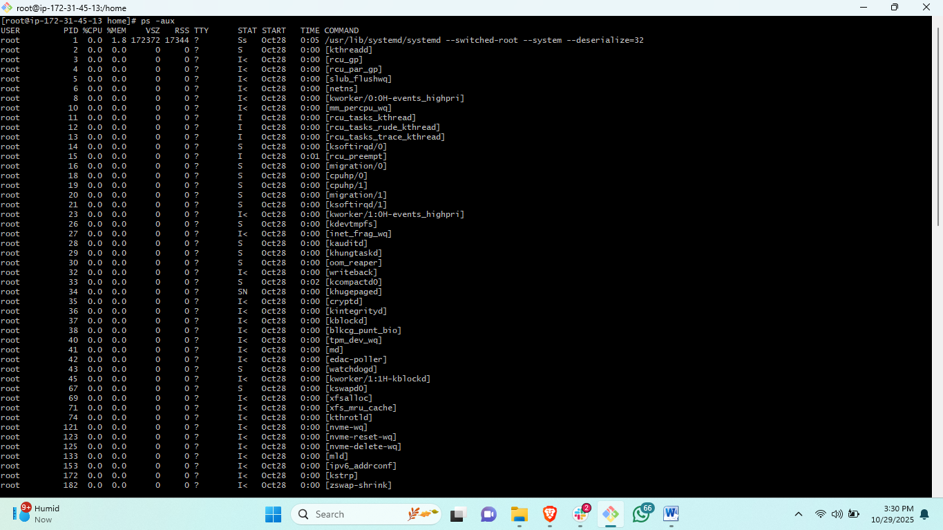 steps: # to check the list of running process <ps -ef> another <ps -aux>
16) Kill a running process.
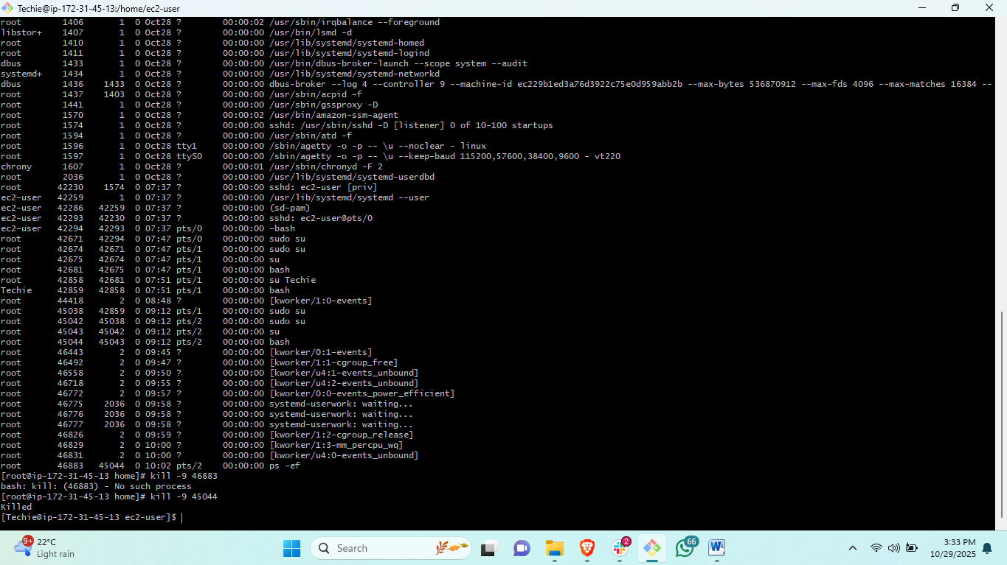steps: # to kill any running process <kill -9 process id>

17) Install a package using the package manager (e.g., apt or yum).
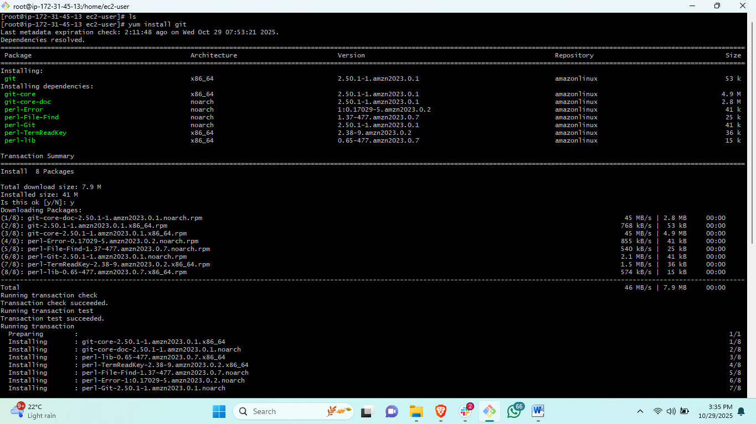steps: steps :# to install any package called git in linux<yum install git>
18) Update the system packages.
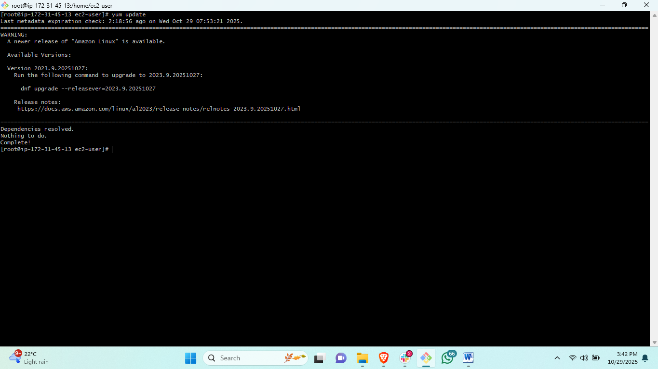steps: # to update the system and packages <yum update>
19) Create a symbolic link.
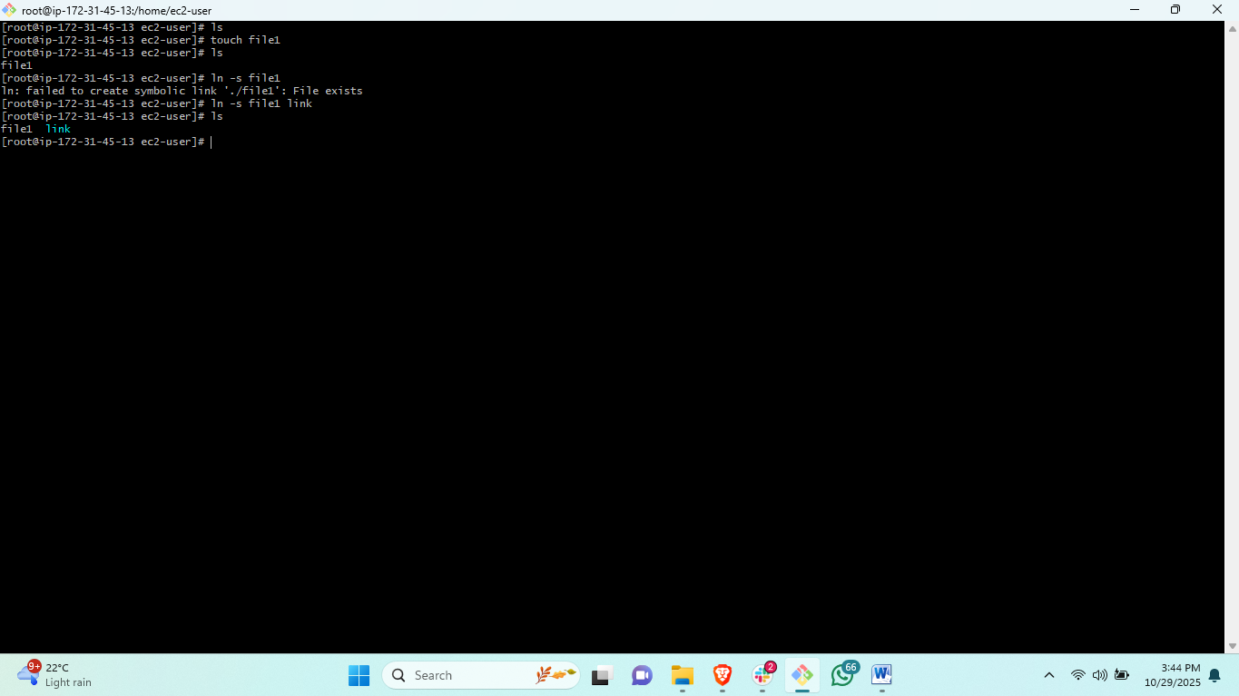steps: # to create a soft link of a file <ln –s filename linkname>
20) Search for files using the find command.
steps: # to find any files and directory If don’t know location<find / -type f –name file name >
21) Compress and decompress files using tar.
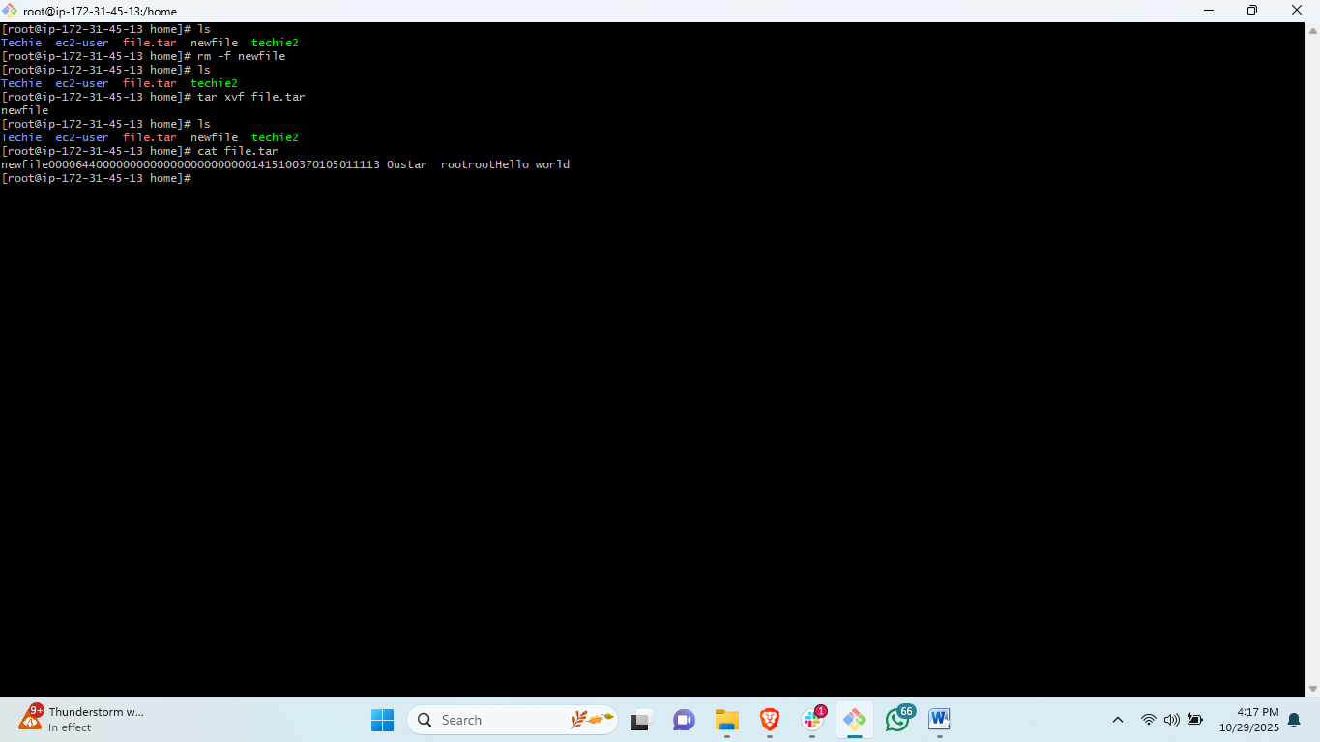steps : # to compress a file <tar cfv file.tar filename> it will create new compress file
# to extract the tar file<tar xvf “tar file name”>
22) Monitor system resources with top or htop.
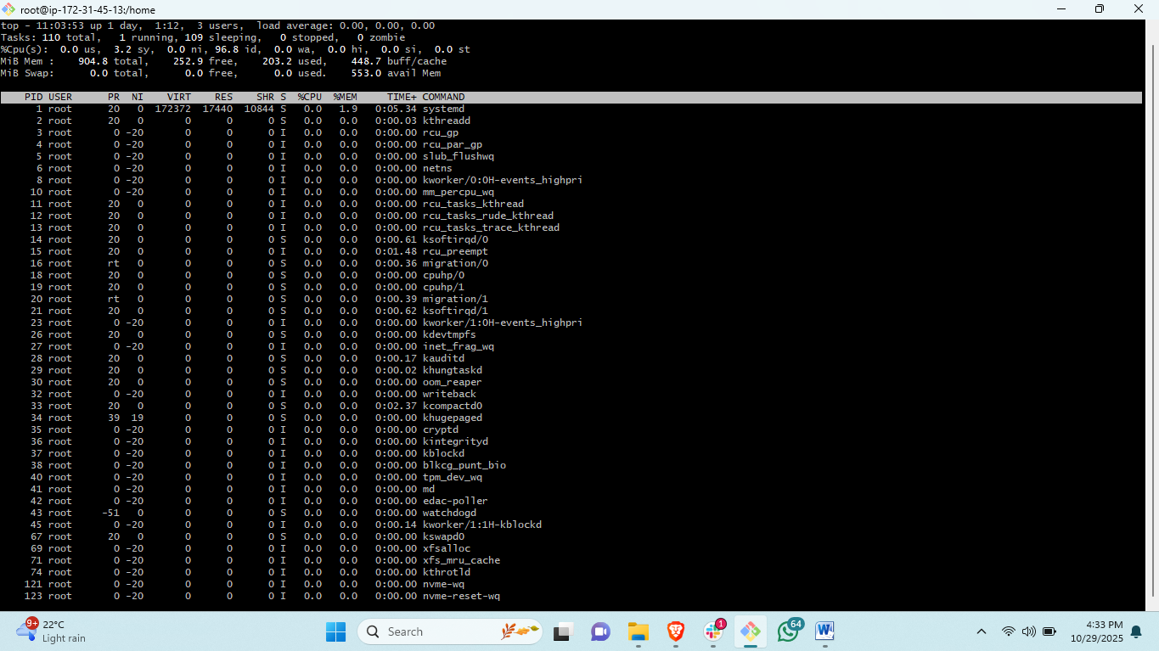steps: # to check monitor the processes continusly <top>
23) Create and manage user groups.
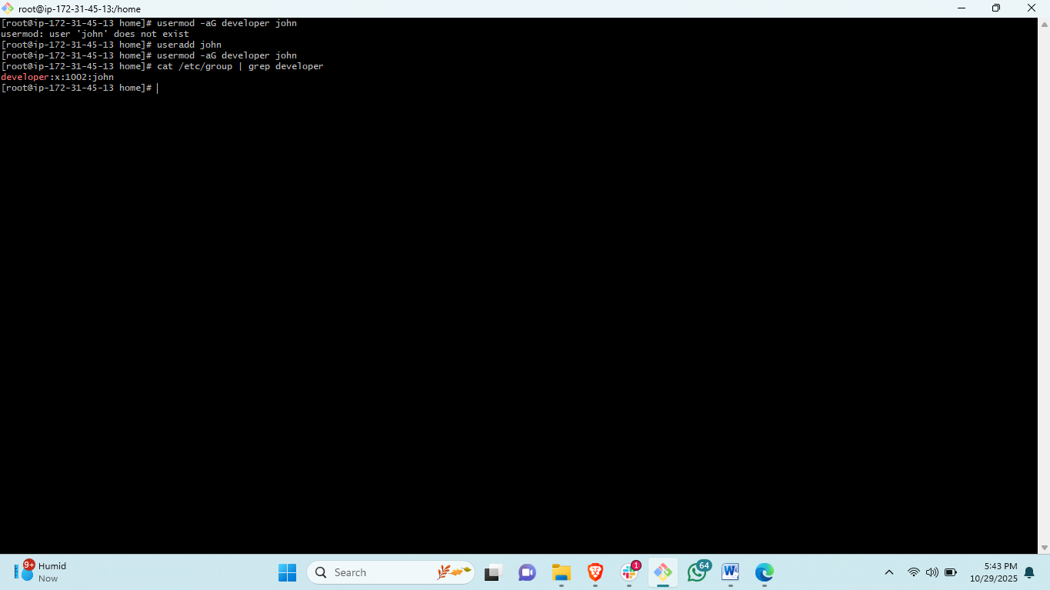
Steps : to create a group <sudo groupadd “group name”>
#to create a user <useradd>
# to add the user in the group <usermod –aG “groupname” “username”>
#to check the group information <cat /etc/group | grep “groupname”>
24) Set up SSH password less authentication.
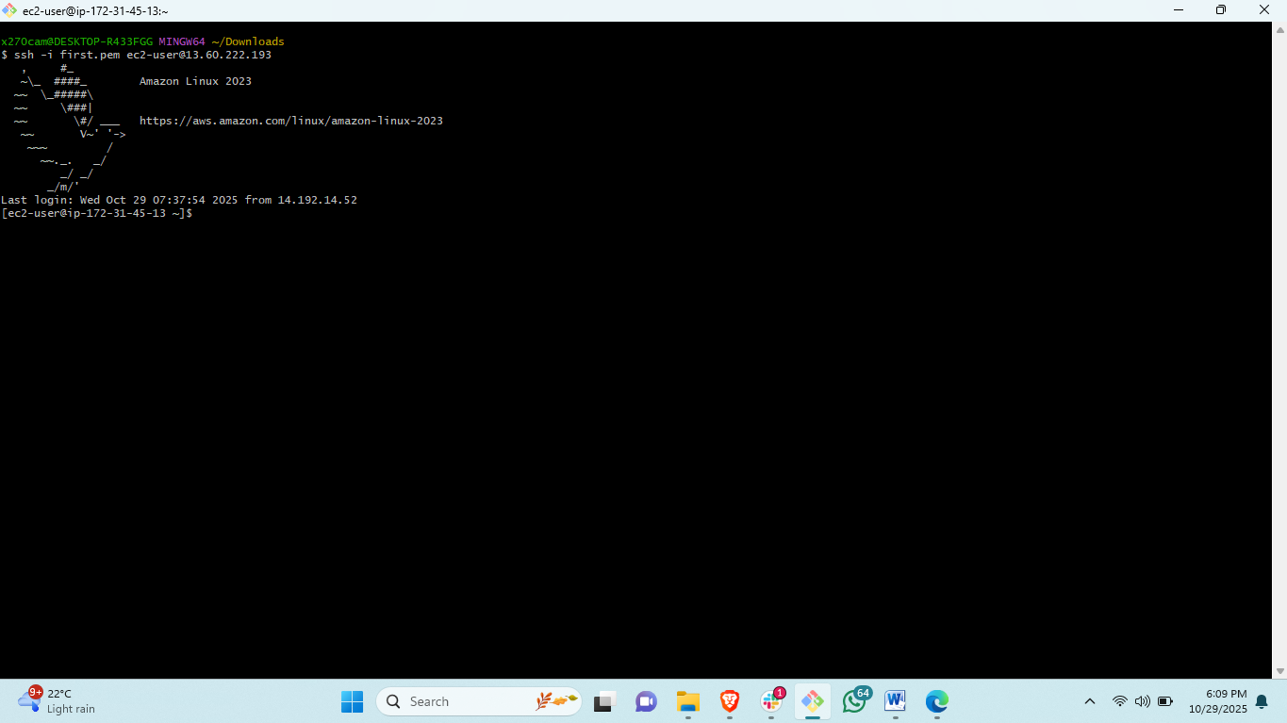 steps: to connect the machine through remote connection through the ssh command.
# to connect ssh connection <ssh -i “pemkey” ec2-user@publicip>
25) Monitor log files using tail or grep.
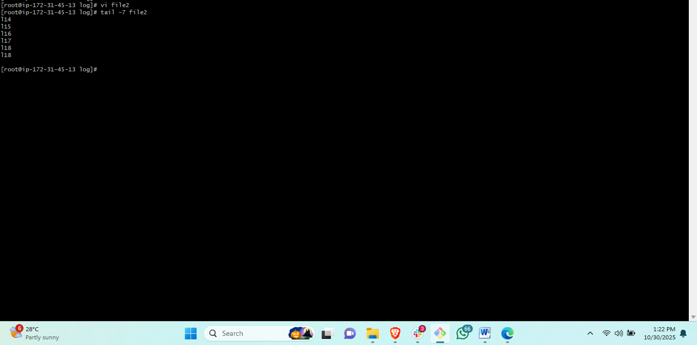steps: if a file contain a lot of line and need to see bottom 7 line <tail -7 filename>
26) Set up a web server (e.g., Apache or Nginx).
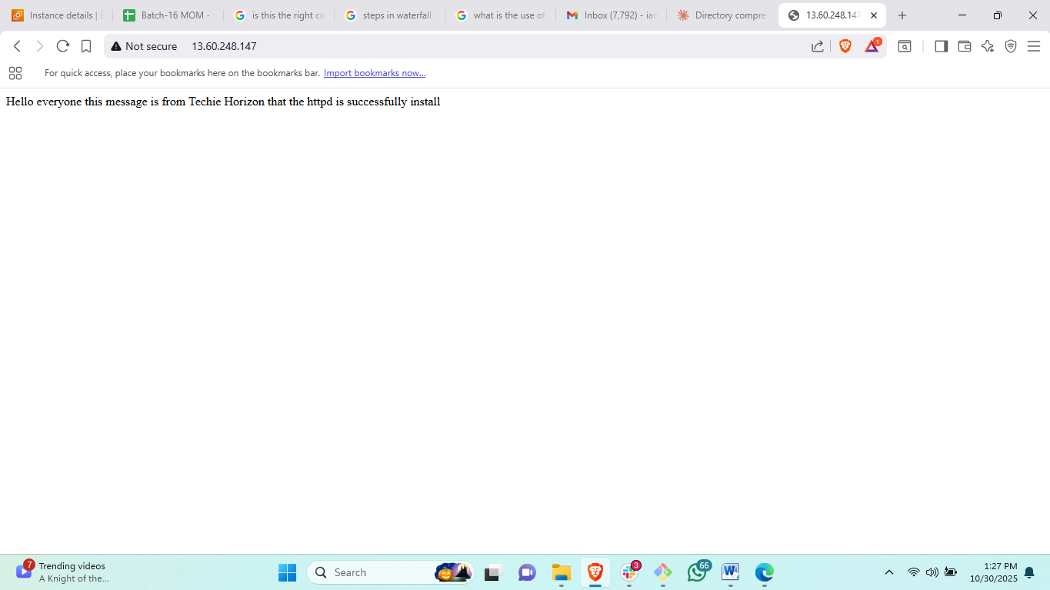steps: to install httpd in your server#<yum update>
Install package of httpd<yum install httpd>
Then start the service<systemctl start httpd>
Then enable service<systemctl enable httpd>
Then copy your public ip and search in your browser.
27) Configure and secure a MySQL Database.

28) Set up a Application Server (e.g.,Apache Tomcat)
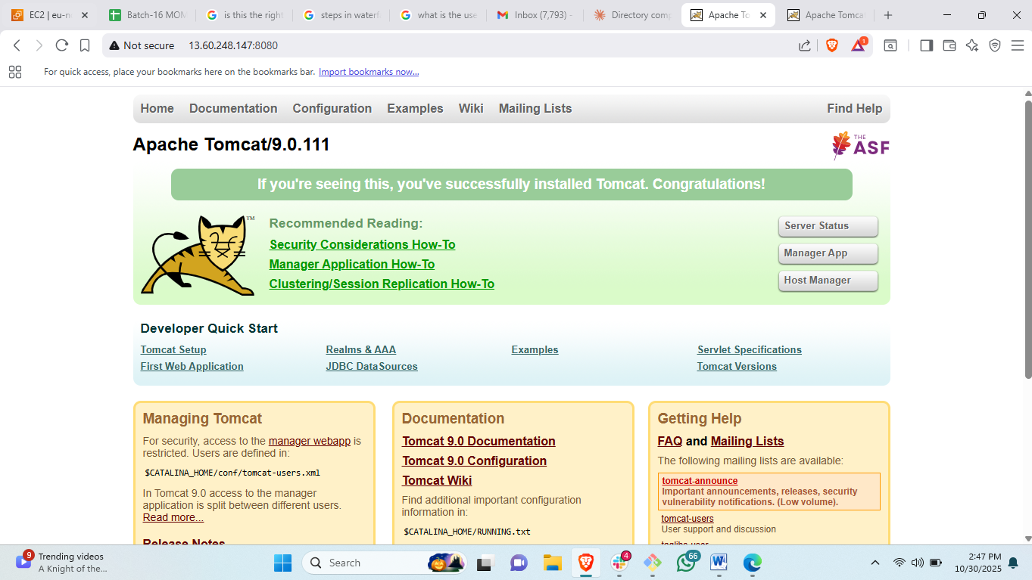steps: first install Java <yum install java-17*>
Then update system <yum update -y> <yum upgrade>
Then # go to opt dir <cd /opt>
Then# install tomcat go to browser and search download apache tomcat 9
Then# copy link address and back to terminal and <wget “pasteURL”>
Then #ls and then untar the downloaded file <tar xvf filename>
Then#rename the untar file to tomcat<mv filename tomcat>
Then #<cd /tomcat/bin>
Then there will be a file called startup.sh start tomcat<./startup.sh>
Go to machine instance and change security credentials and add security inbound rules.
29) create a service file for Apache Tomcat.(Should execute by using systemtctl command)
30) Print specific columns from a delimited file.
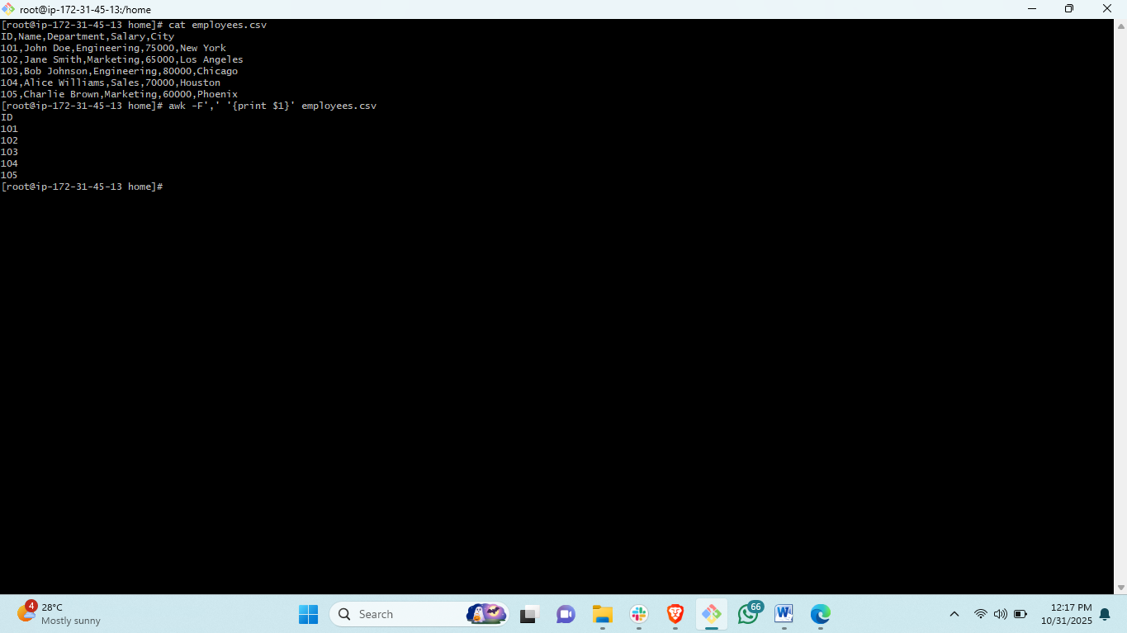steps:# to print the specific column in a file is very helpful if a file contain a lot of information it is complex to understand<awk -F',' '{print $1}' employees.csv>
31) Filter and print lines based on a specific pattern or condition
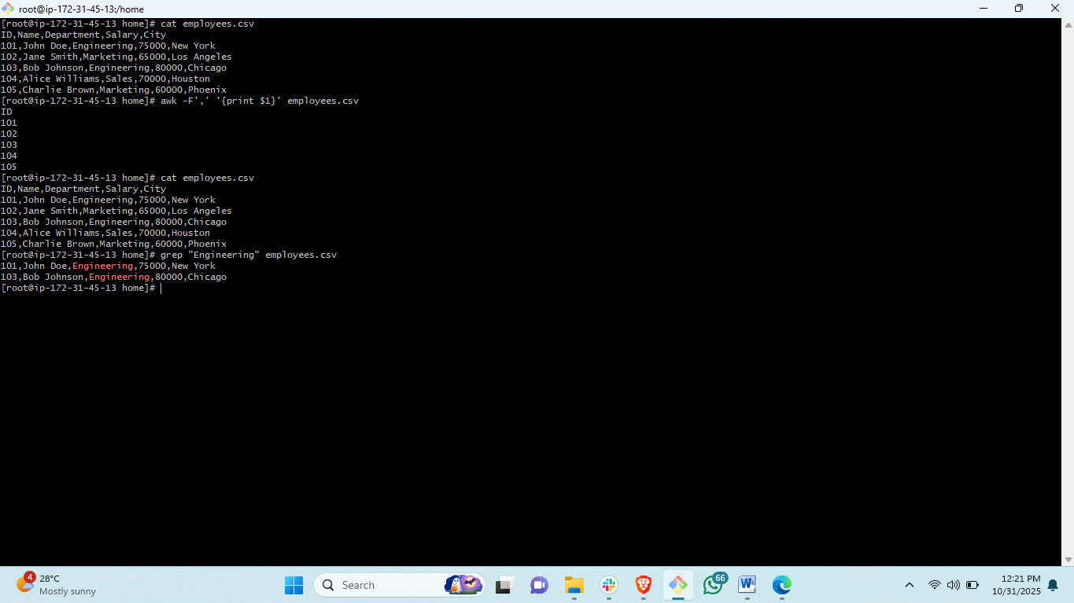steps: to filter the line based on specific keyword<grep "Engineering" employees.csv>

32) Calculate and print the average, sum, or other statistics of a column.
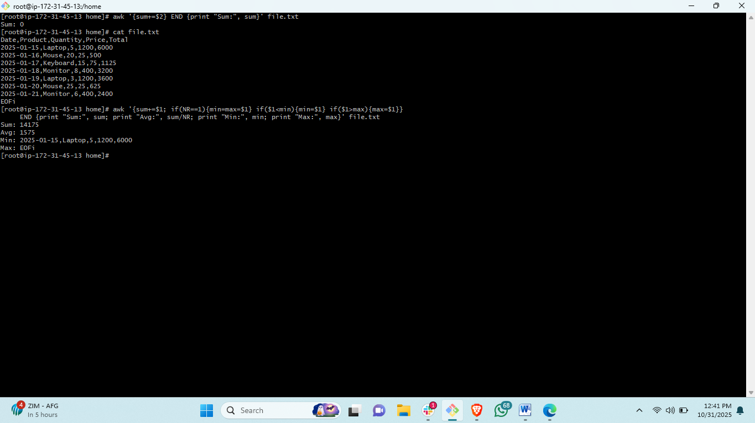steps: to calculate and print the average sum or other statistics of a column <awk '{sum+=$2} END {print "Sum:", sum}' file.txt>
33) Perform string manipulation, such as extracting substrings or changing case.
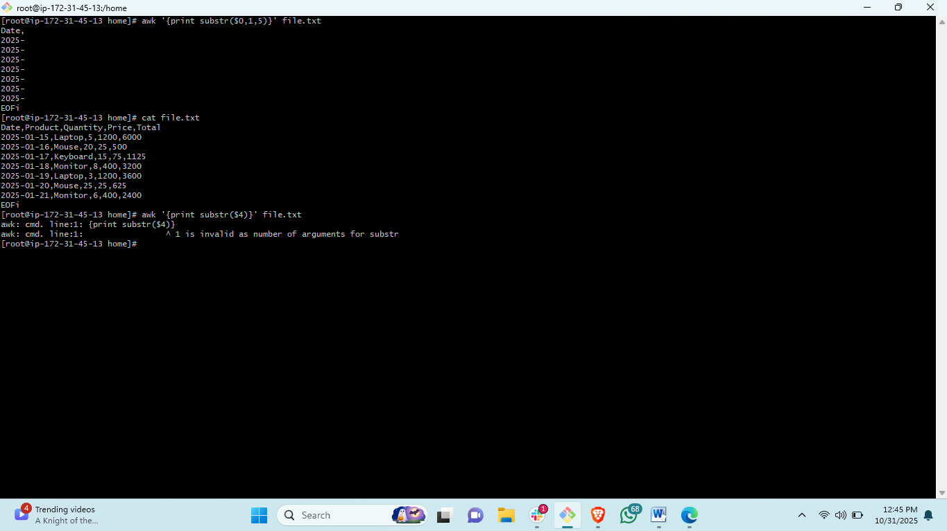steps: awk '{print substr($0,1,5)}' file.txt
34) Count the occurrences of a specific pattern in a file.
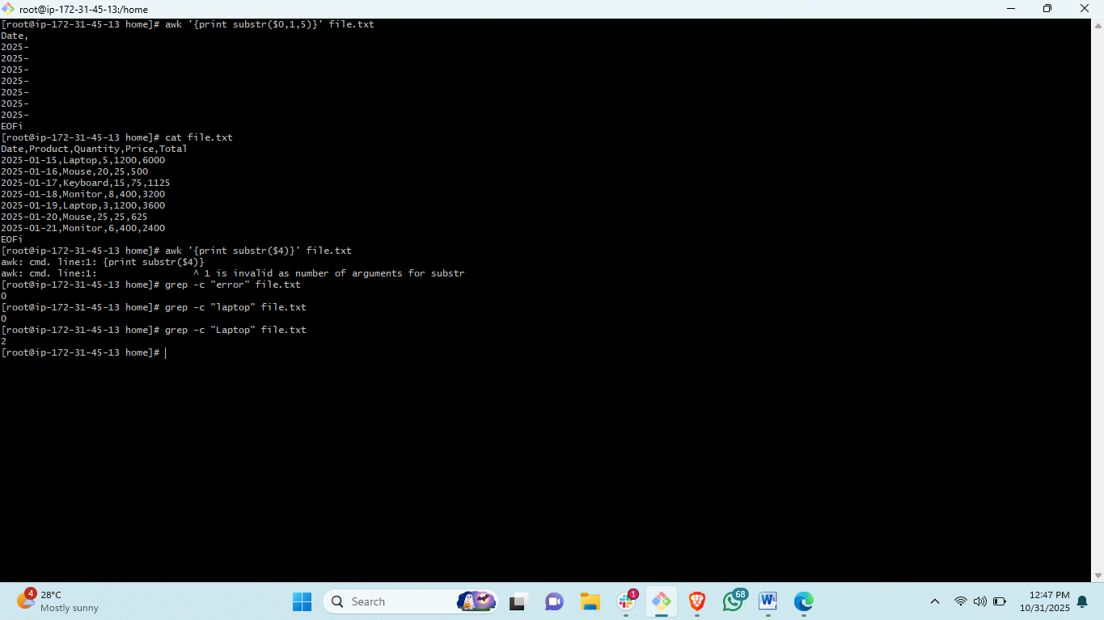steps: tgrep -c "error" file.txto count the keyword that how many times it is repeating <grep -c Laptopr" file.txt>

35) Sort lines based on a specific field or column.
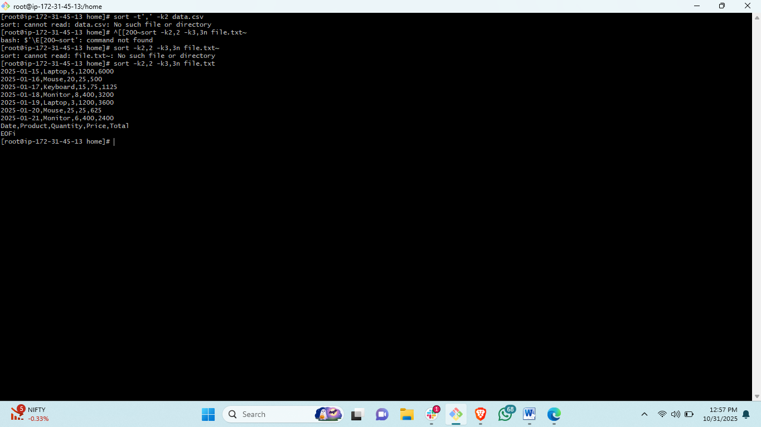steps : <sort -k2,2 -k3,3n file.txt>
36) Merge multiple files based on a common field or column.
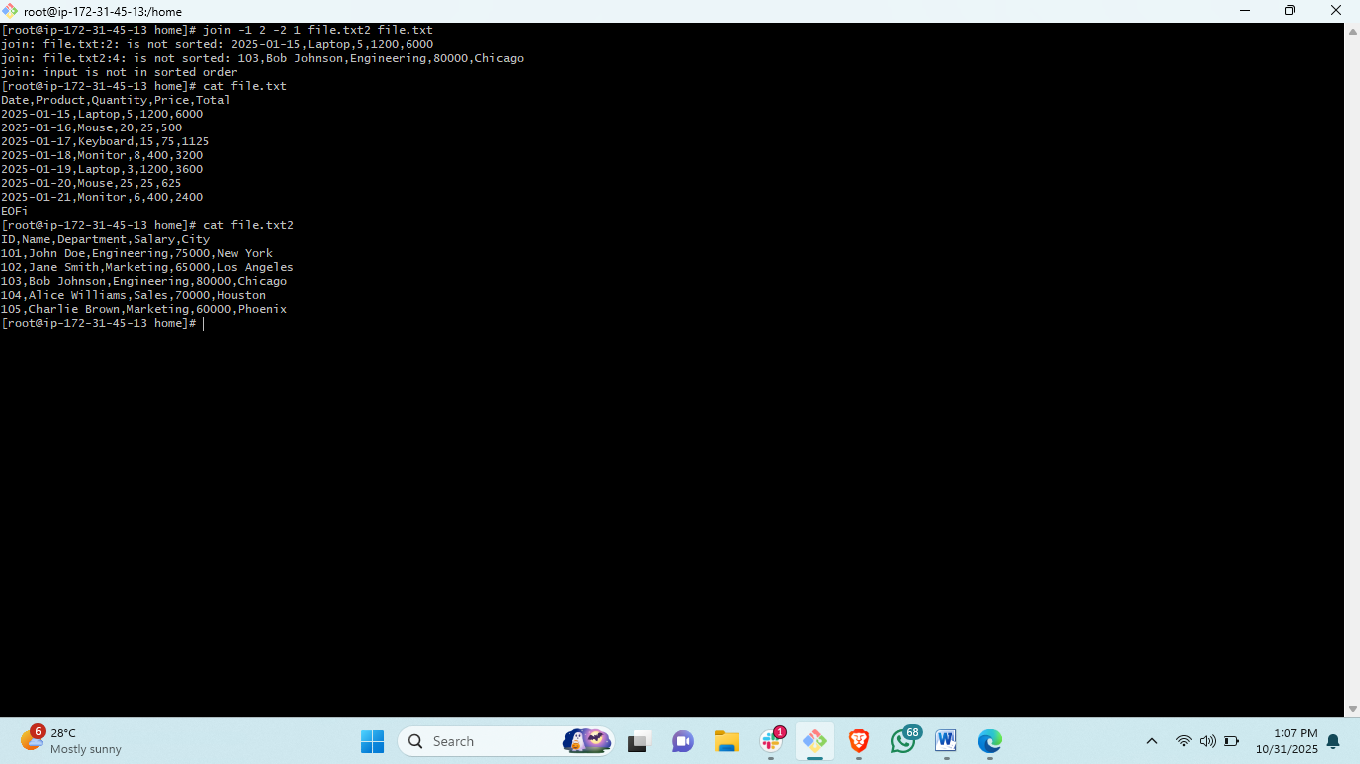steps: to merge two file on lines based<join -1 2 -2 1 file1.txt file2.txt >
37) Substitute text in a file using search and replace.
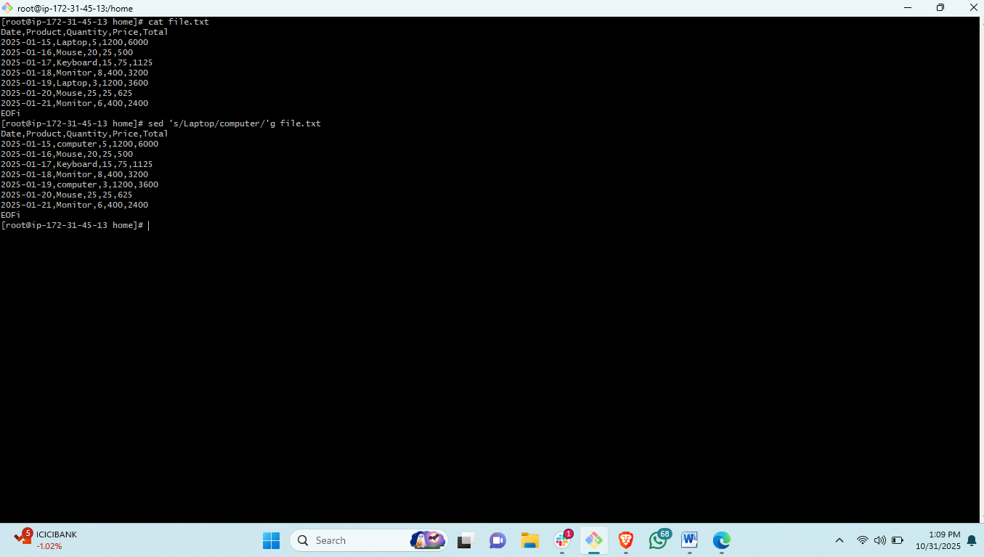steps: to change a replace keywork in a file<sed ‘s/oldname/newname/’g filename>
38) Delete specific lines based on a pattern or line number.
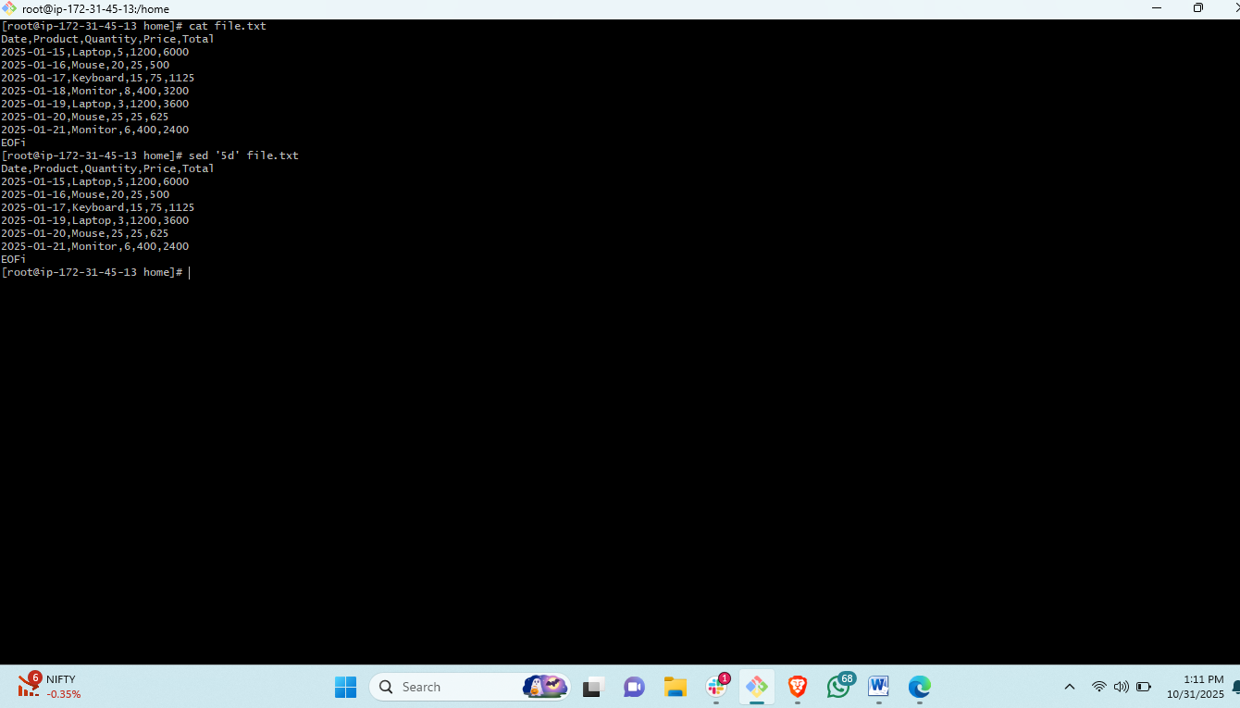STEPS:#to delete the perticuld=ar line in a file <sed ‘5d’ filename>
39) Append or insert text before or after a specific pattern or line.
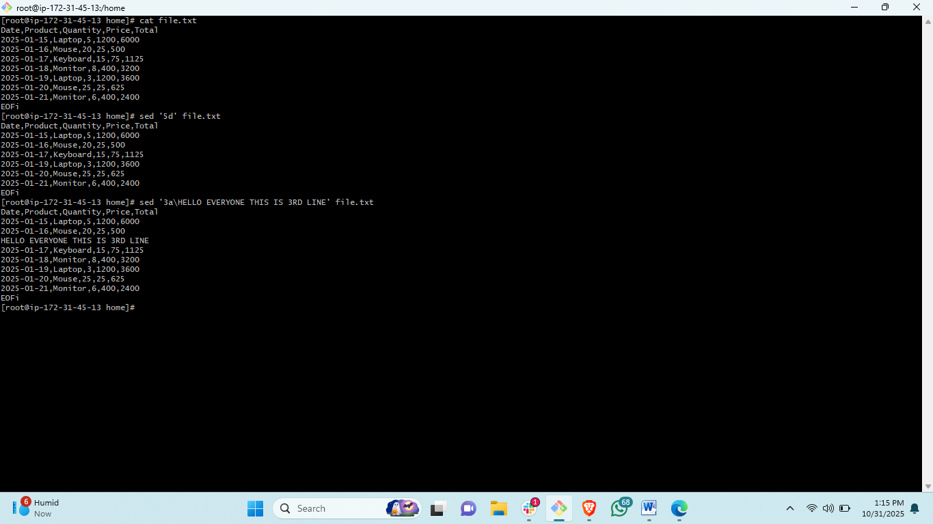STEPS: to add a line in file along with the content<sed '3a\New line text' file.txt>
40) Print only specific lines from a file.
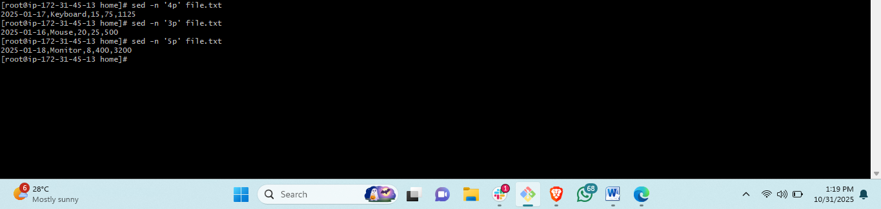steps:to print the specific columb <sed -n '5p' file.txt>
41) Copy file from linux to windows machine
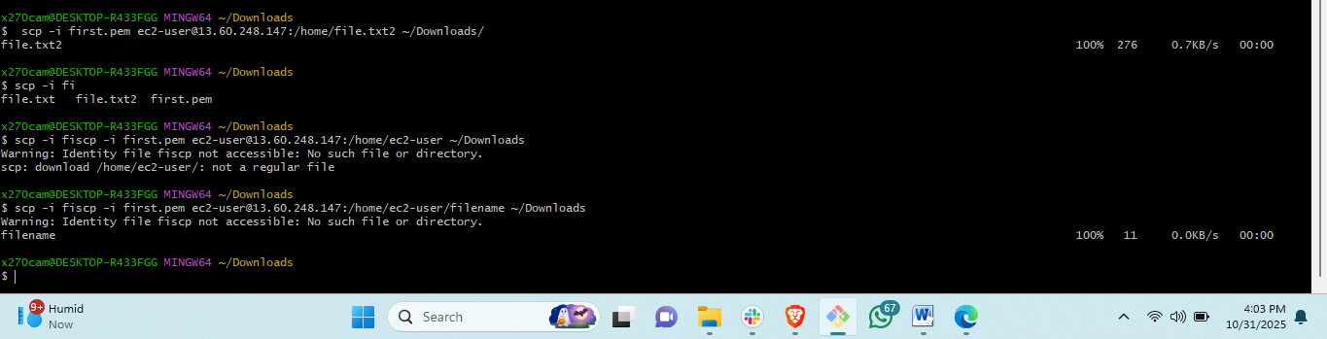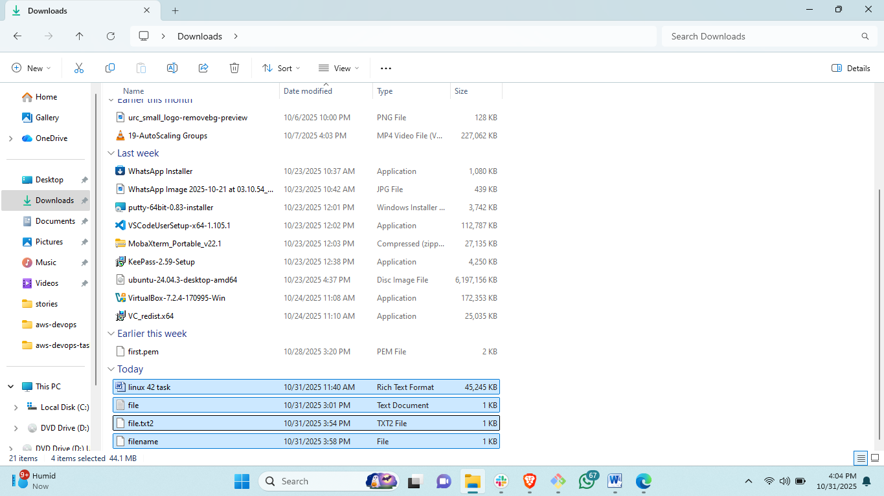steps : to copy the file or directory from linux server to own pc
<SCP –I PEM.KEY ec2-user@ip/filelocation/filename ~/destination/>
42) 5 use cases for AWK and 5 use cases for sed
AWK Use Cases:
1. # Analyze Apache access logs
awk '{print $1, $7, $9}' /var/log/apache2/access.log | sort | uniq -c
2. # Calculate bandwidth usage by IP
awk '{bytes[$1]+=$10} END {for(ip in bytes) print ip, bytes[ip]/1024/1024 "MB"}' access.log
3. # Disk usage analysis
df -h | awk '$5+0 > 80 {print $1, $5, "WARNING: High disk usage"}'
4. # Format financial data
awk '{prin� "%-15s $%8.2f\n", $1, $2}' financial_data.txt
5. # Convert between different date formats
echo "2024-03-15" | awk -F'-' '{print $2"/"$3"/"$1}'
SED Use Cases:
1. # Add configuration if it doesn't exist
sed -i '/^#Port/a Port 2222' /etc/ssh/sshd_config
2. # Extract error messages only
sed -n '/ERROR/p' applica�on.log > error_log.txt
3. # Remove comments from code files
sed -i '/^[[:space:]]*#/d; s/#.*$//' script.py
4. # Normalize text case and spacing
sed 's/[[:space:]]\+/ /g; s/^ //; s/ $//' text_file.txt
5. # Update version numbers in multiple files
sed -i 's/version = "1\.0\.0"/version = "1.1.0"/g' *.py *.js *.json

